*E-commerce Website for AMIT  
Using Django and React*

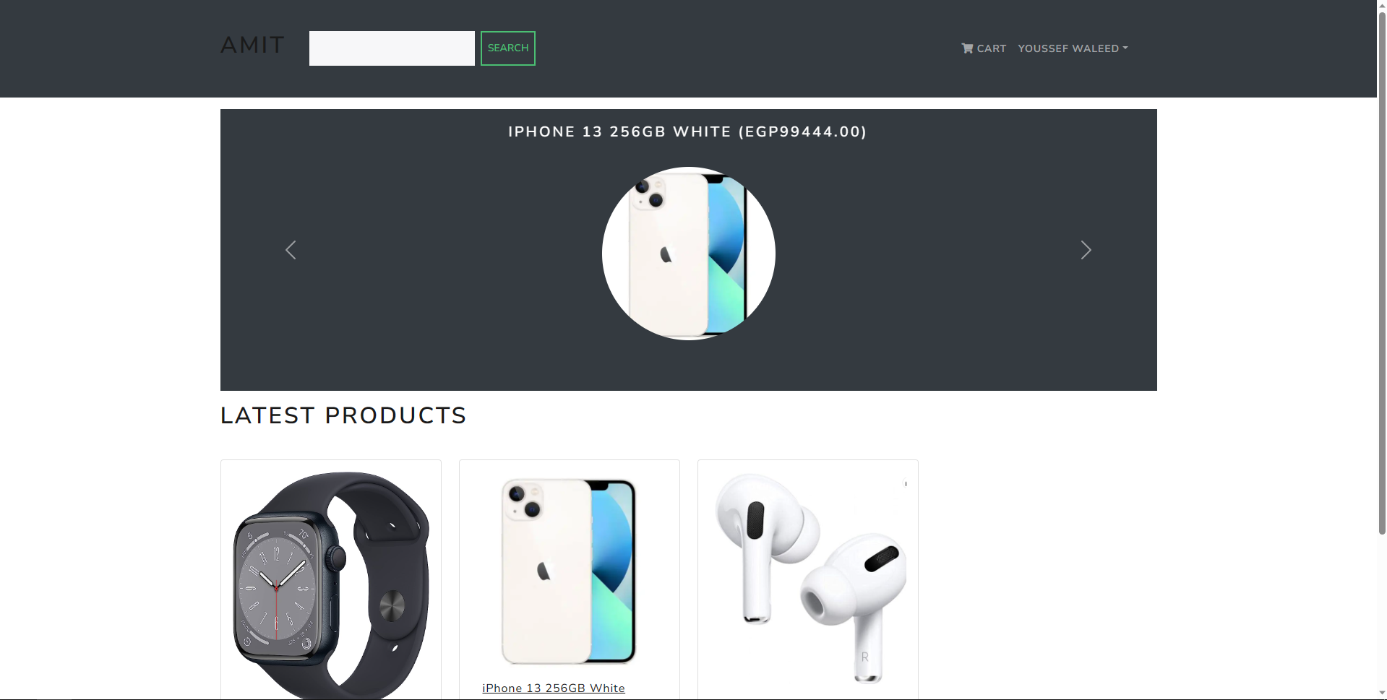

Product Catalog (Home Page): The web application has a product catalog that allows customers to browse and search for products. The catalog should include product description, images, prices, rating, and available quantity of each product. And when you click on each product you should see the page of this product including image of product, product full description, and related products if available.

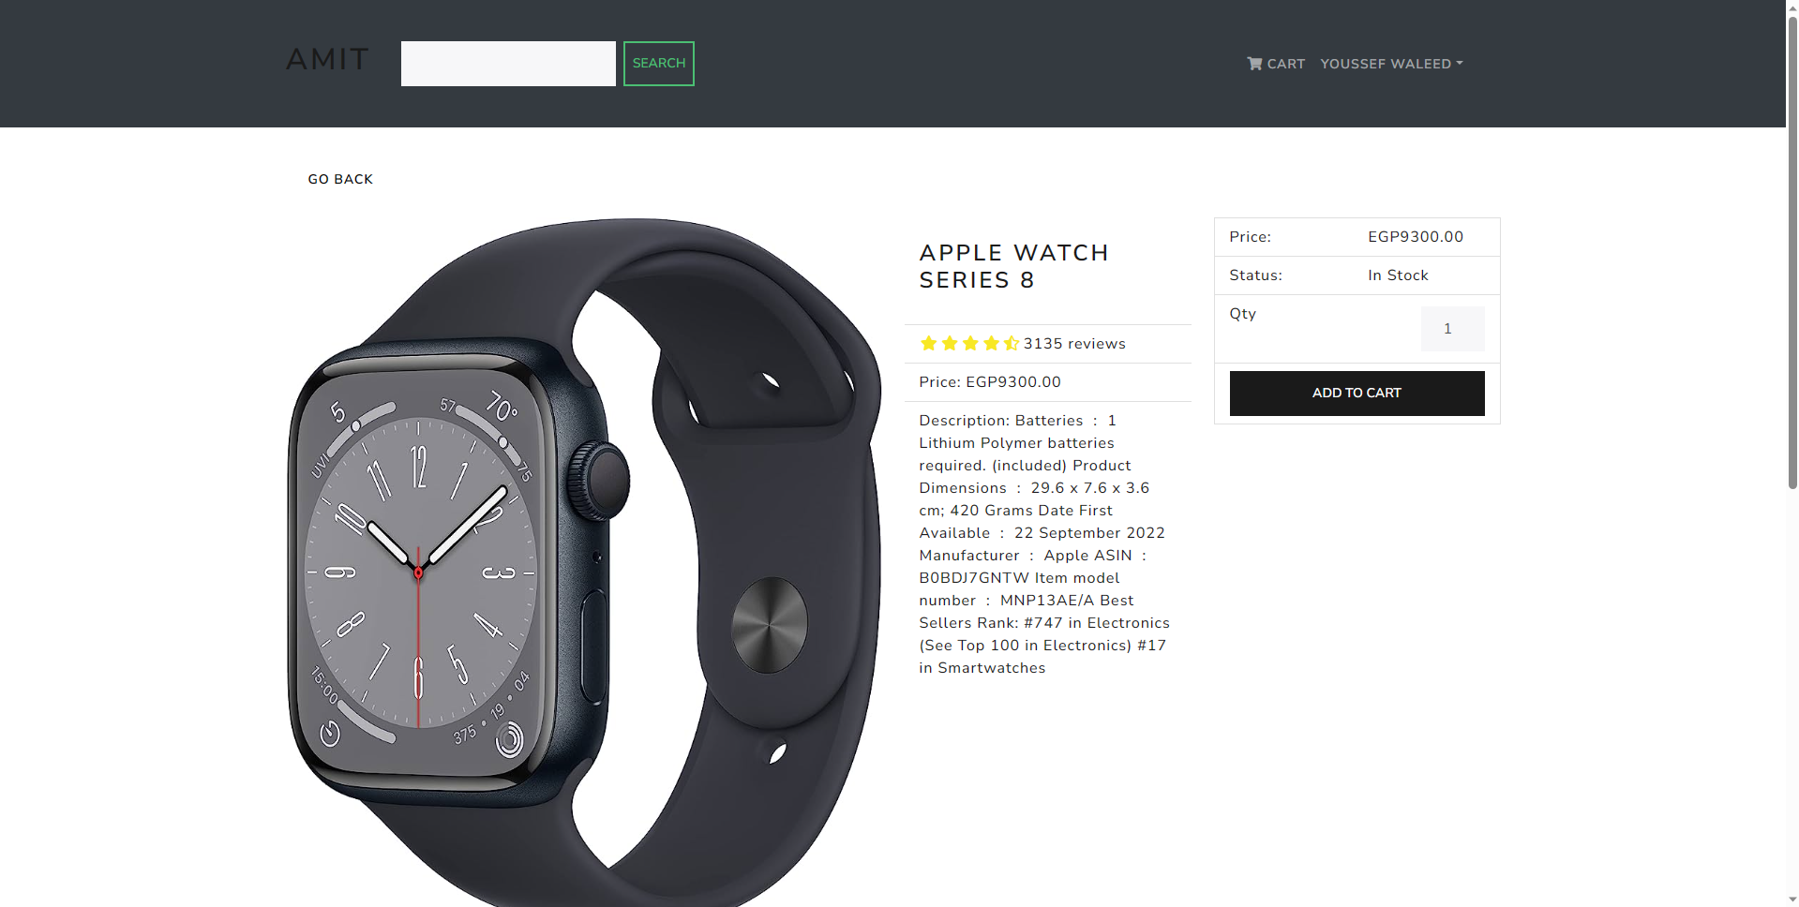

Shopping cart: The application has a shopping cart that allows customers to add products to their cart and manage their orders.

User profile: Users can change their profile’s password and check for products they ordered and if they’re paid and delivered or not.

Order management: The application should have an order management system that allows users to manage orders.

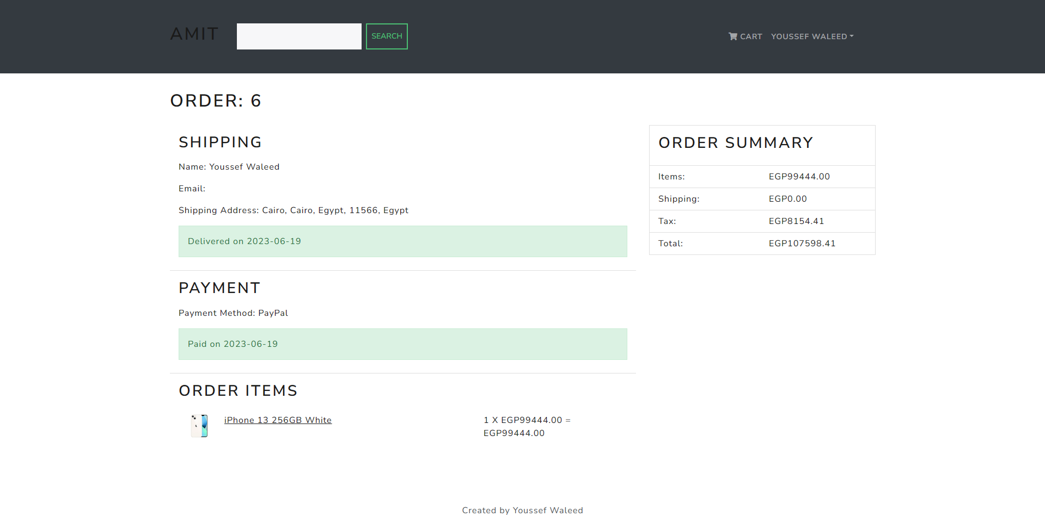

User registration and authentication: The application should provide user registration and authentication features to allow customers to create accounts, sign in, and manage their proﬁles.

Notice: users can update their proﬁles.

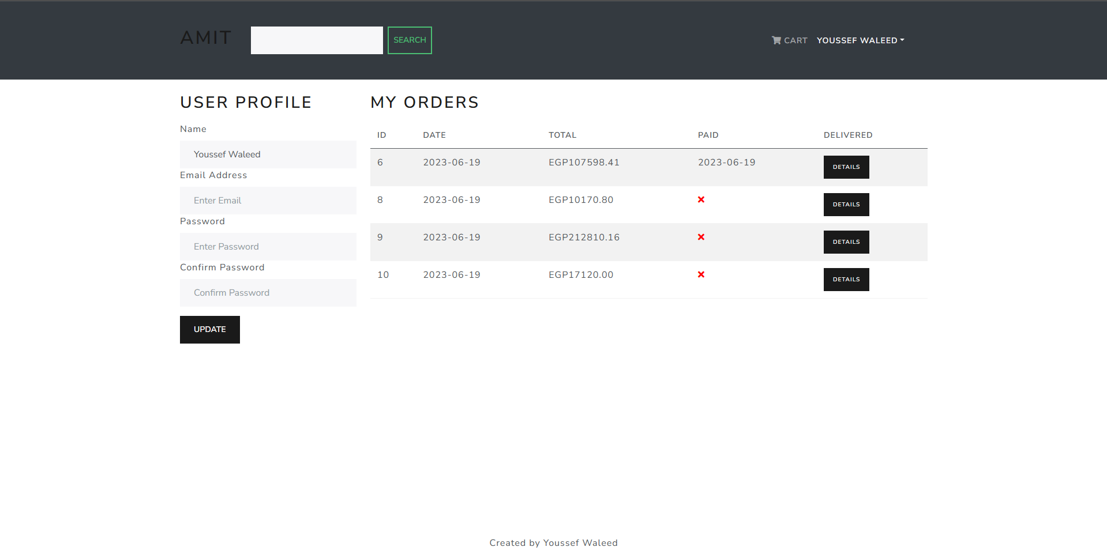

Responsive design: The application should have a responsive design that works well on diﬀerent devices and screen sizes, including desktops, laptops, tablets, and smartphones.

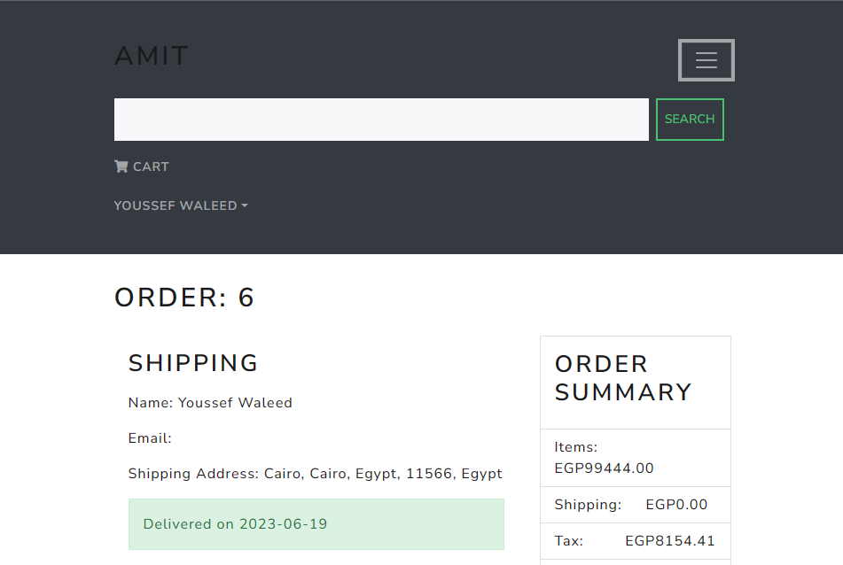

Order management: like users, The application has an order management system that allows administrators to manage orders, track shipments to see each order status.

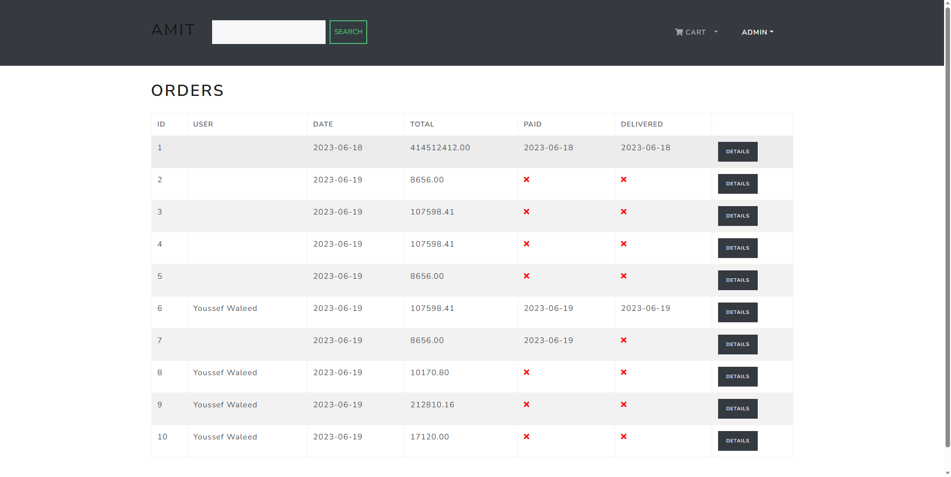

Products: The administrators should see all products to add new product, edit existing product or delete existing product.

